CIRCUIT SYMBOLS

Circuit diagrams make it easier to assemble and understand how circuits work.

The following symbols need to be memorised.

Notice that some components have two possible symbols - either is acceptable.

e.g. Look at light globes, resistors and variable resistors.

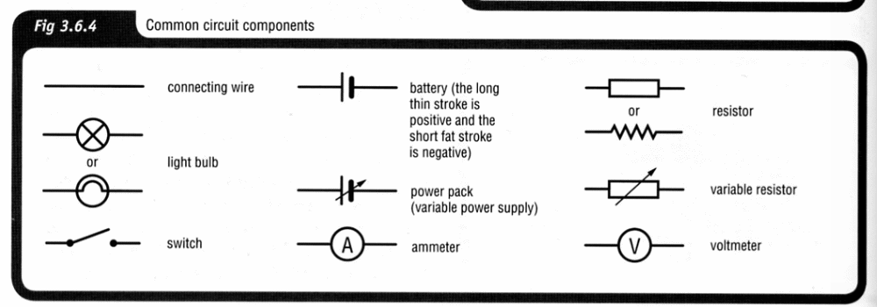

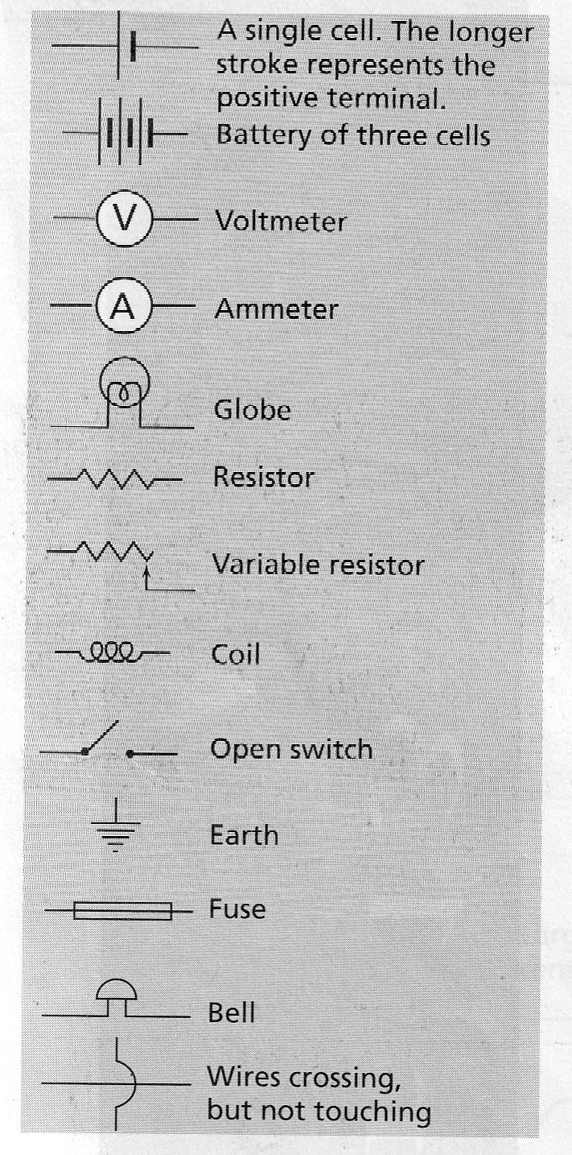
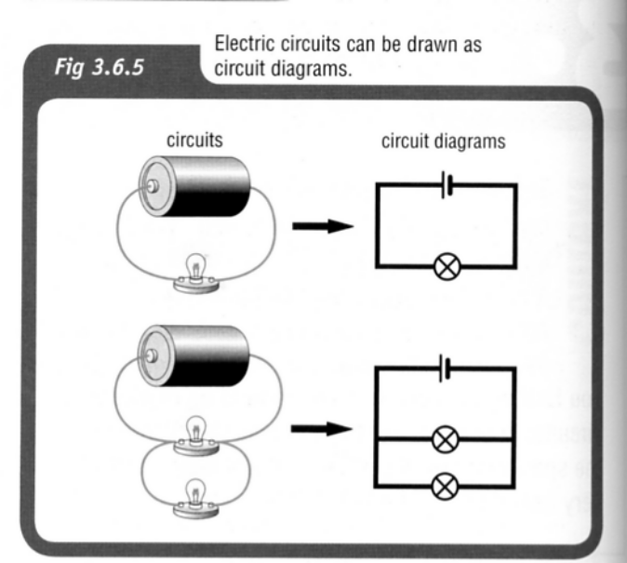
Below are two examples of drawing simple circuits.

